Store Clark

Generate Report

Click “Generate Report” link from menu to generate report.

Select Inventory Status Report to generate the inventory status report.

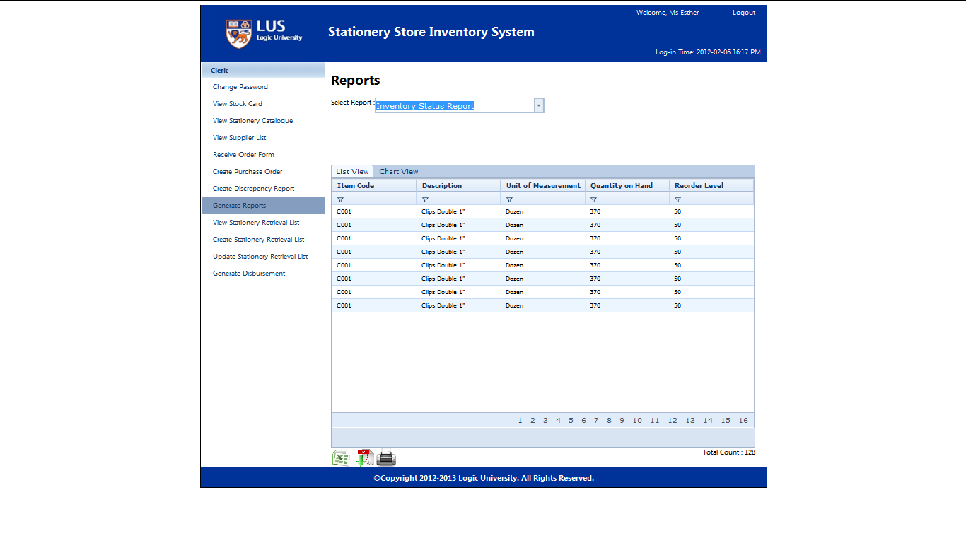

Select Reorder Report to generate the reorder report.

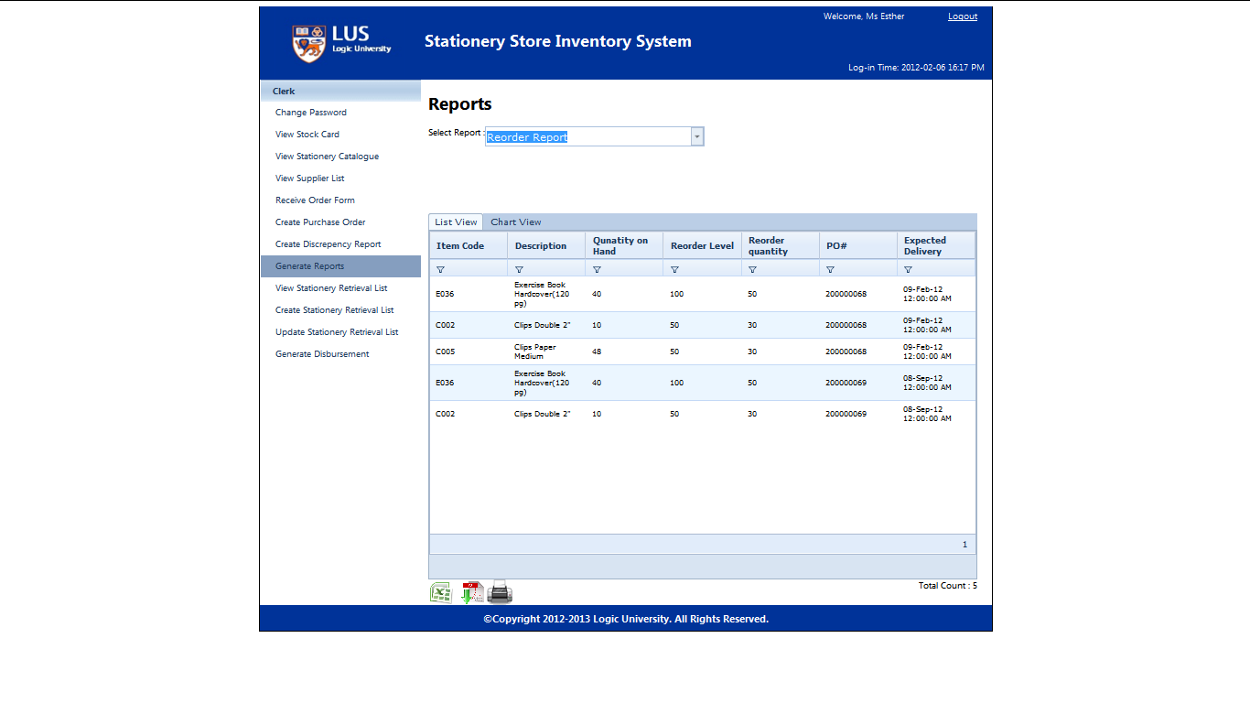

Select Item Consumption Report to generate the item consumption report.

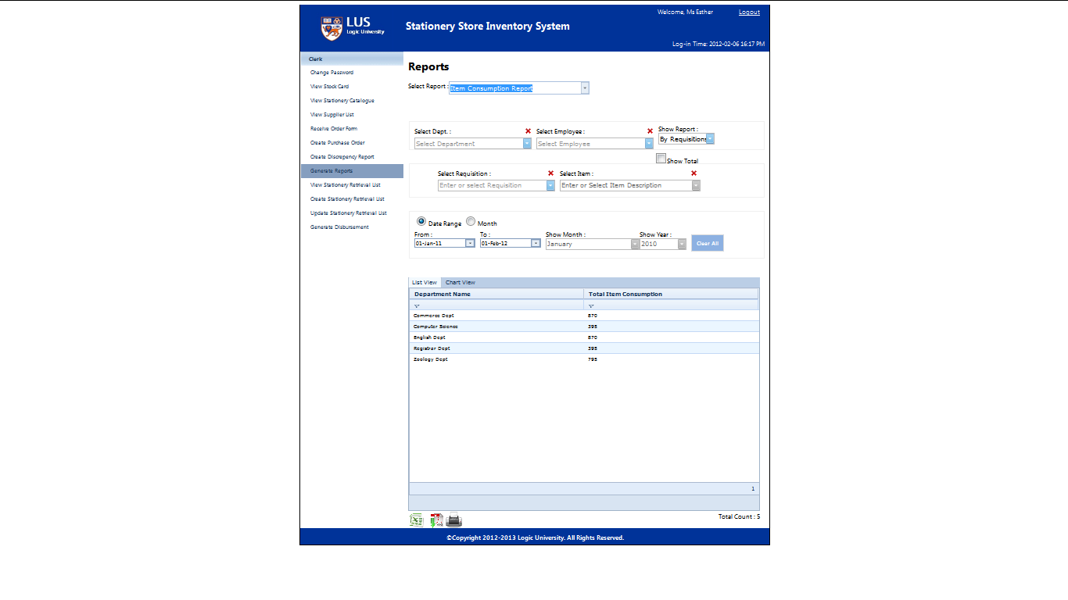

Select the department to generate the item consumption report for the selected department.

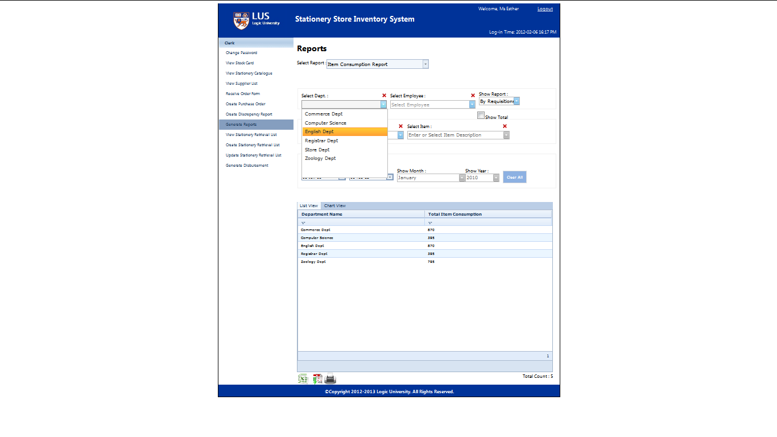

Select department, employee, show report, requisition, Item and date range to generate the item consumption report by desire format.

(Screen not show)

Select Disbursement List to generate the disbursement list report.

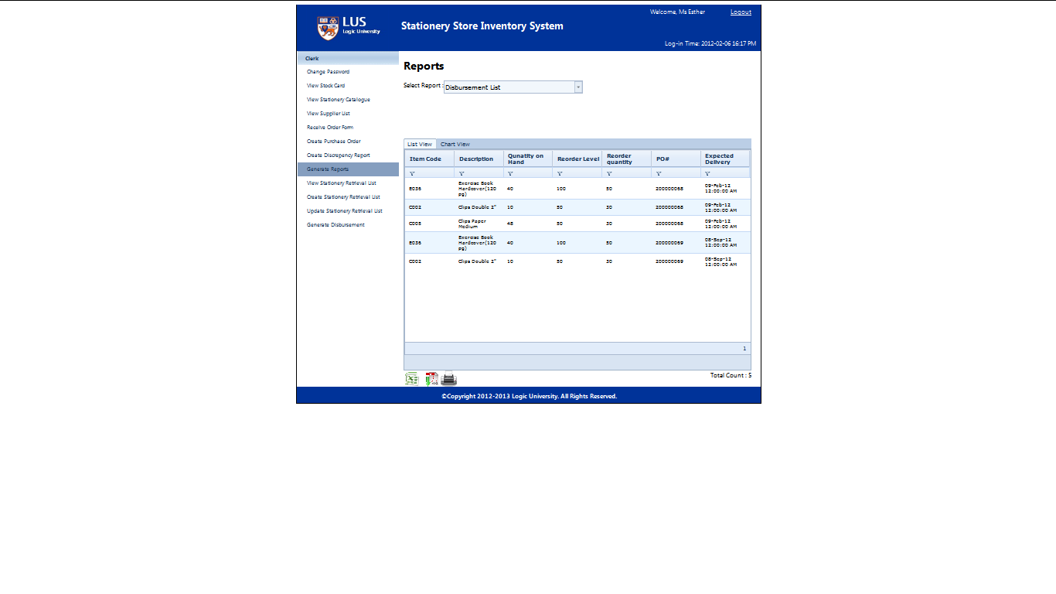

Select Stationery Catalogue to generate the stationery catalogue report.

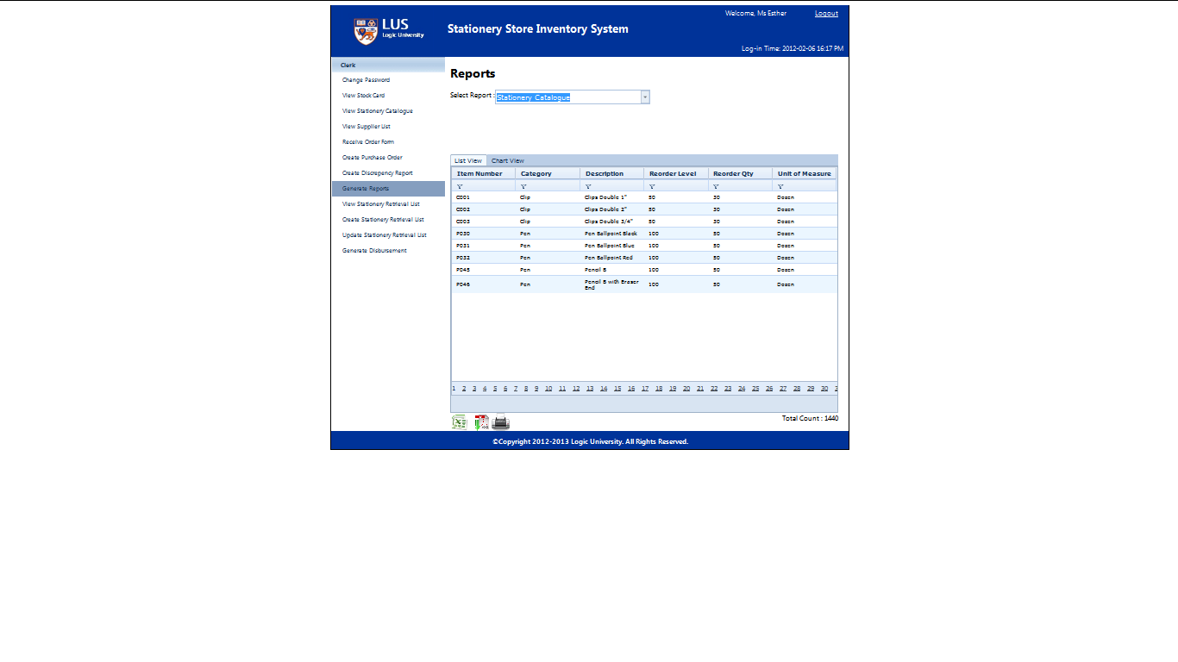

Select Stationery Supply Tender Form and Supplier to generate the stationery supply tender report.

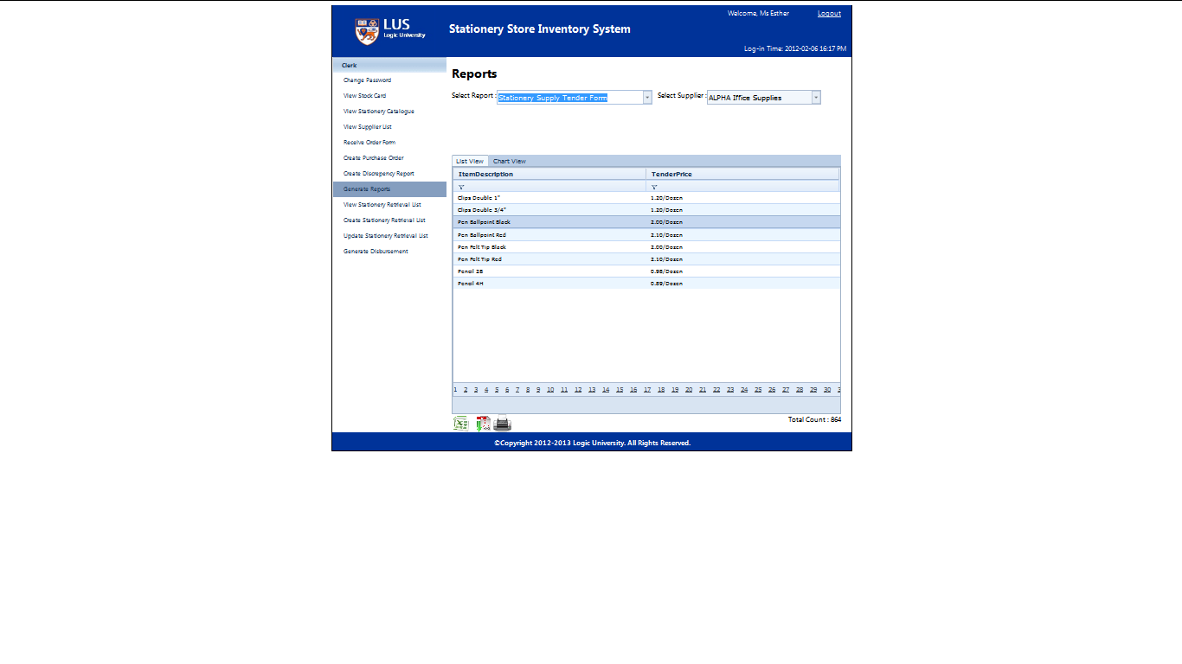

Select Collection List to generate the collection list report.

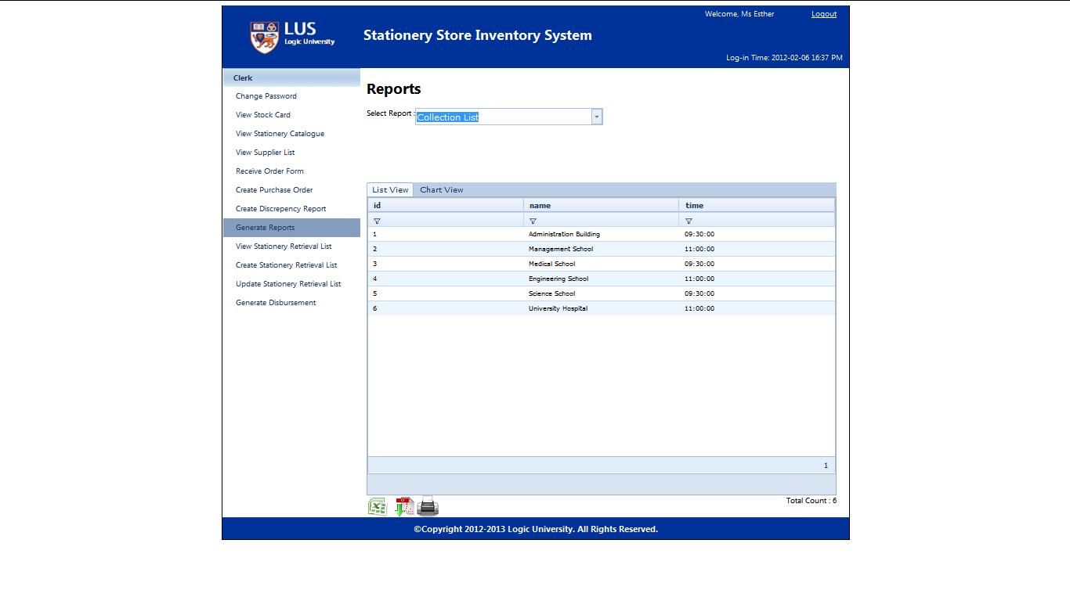

Select Employees List to generate the employee list report.

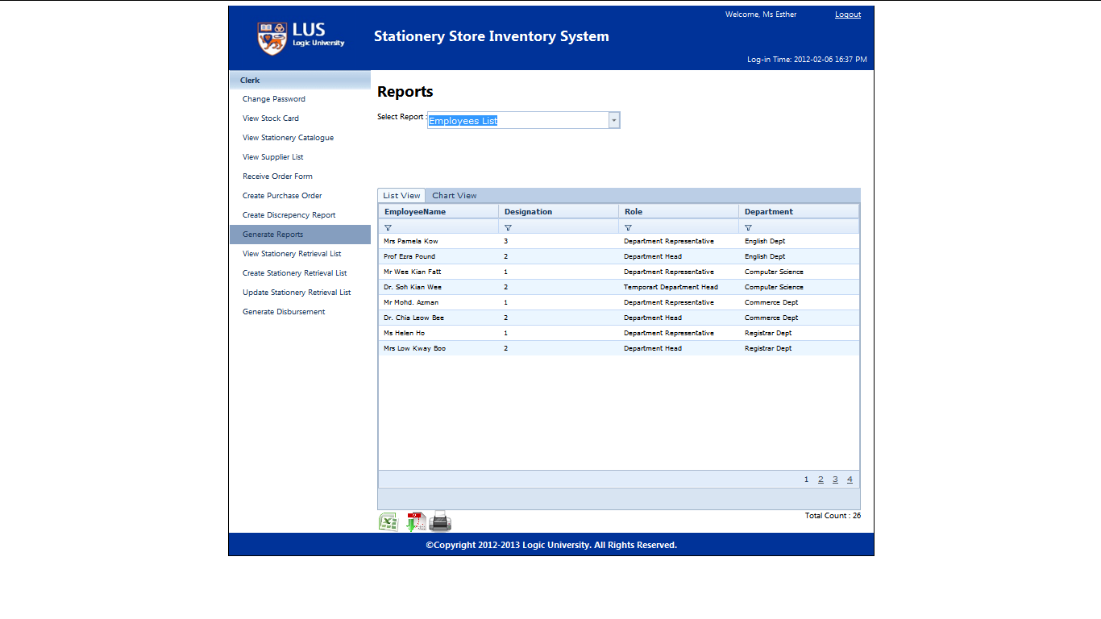

Select Department List to generate the department list report.

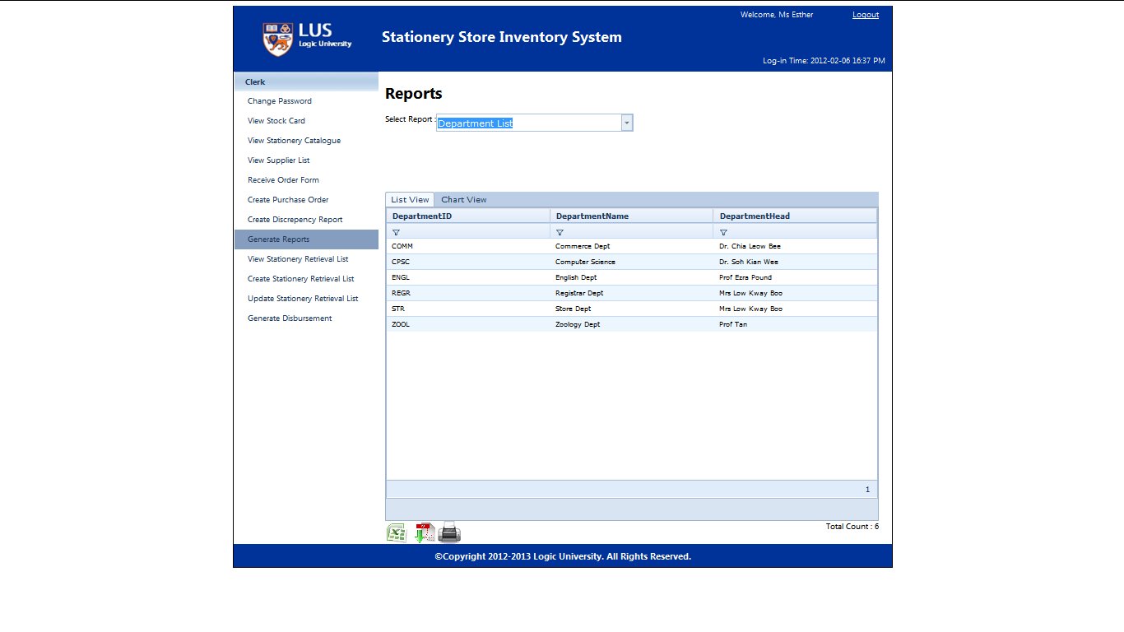

Select Requisition List to generate the requisition list report.

(Screen not show)

Select Supplier List to generate supplier list report.

